BIOE 301 Name:
Exam 1
February 2, 2006

The exam consists of 10 questions on xx pages. Show all work to receive credit. Clearly organize your work and draw a box around your final answers. NEATNESS COUNTS! Good Luck!

Problem 1 (6):

Problem 2 (15):

Problem 3 (15):

Problem 4 (9):

Problem 5 (6):

Problem 6 (10):

Problem 7 (10):

Problem 8 (8):

Problem 9: (12):

Problem 10 (9):

Extra Credit (2):

Total (100):

- In class, we found that road traffic accidents are a leading cause of death for young people.

  - How do motorcycle helmets work to save lives? How did our demonstration with the egg illustrate this?

  - Why do factors which slow driver reaction time lead to increased crash frequency and crash severity? Name three factors which slow driver reaction times.

  - Compare trends in motor vehicle related mortality rates in developed and developing countries over the past ten years. What factors do you think contribute to these differences?

- The AIDS pandemic is a worldwide problem. An estimated 40 million people are living with HIV/AIDS and over 20 million deaths have been associated with this disease.

  - Which component of the immune system is selectively targeted and destroyed by HIV?

  - Sketch a plot showing (1) the viral load and (2) blood count of the cell type specified in part (a), over the time course of the disease. On the plot identify the acute phase of the infection, the latent period, and full-blown AIDS.

  - What is the approximate length of the latent period? Can HIV be transmitted during this time?

  - There are several potential strategies for preventing retrovirus replication. On the diagram below, indicate (with arrows) three stages targeted and name the type of each type of inhibition. (Hint: Drugs have been developed to interfere with 2 different parts of the replication process, and drugs blocking 2 other stages of the cycle are currently in development).

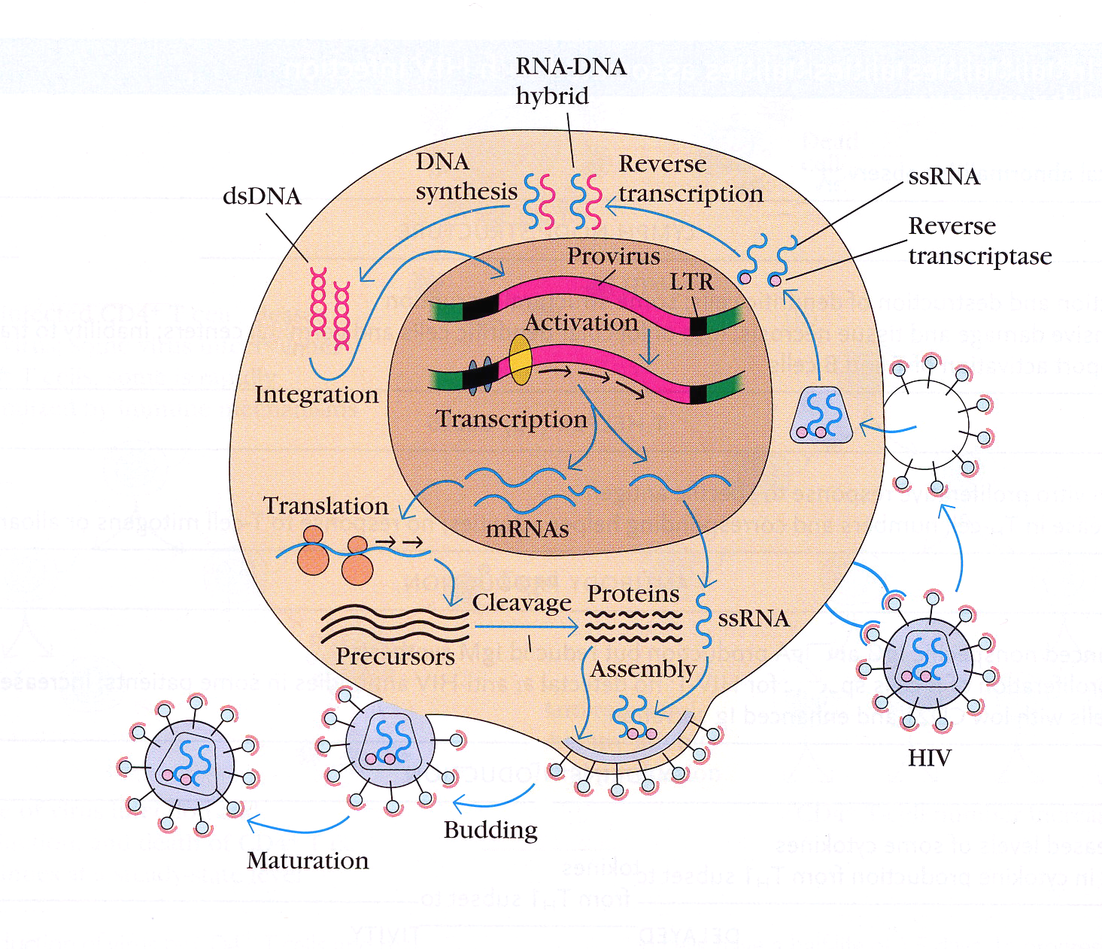

  - Combination therapies have been successful in suppressing viral levels. What is the name of the current treatment strategy and why is it so effective? You may want to reference Dr. McCurdy’s discussion for selecting treatment options for tuberculosis.

  - Discuss the WHO 3x5 initiative and comment on the current progress and challenges associated with this effort.

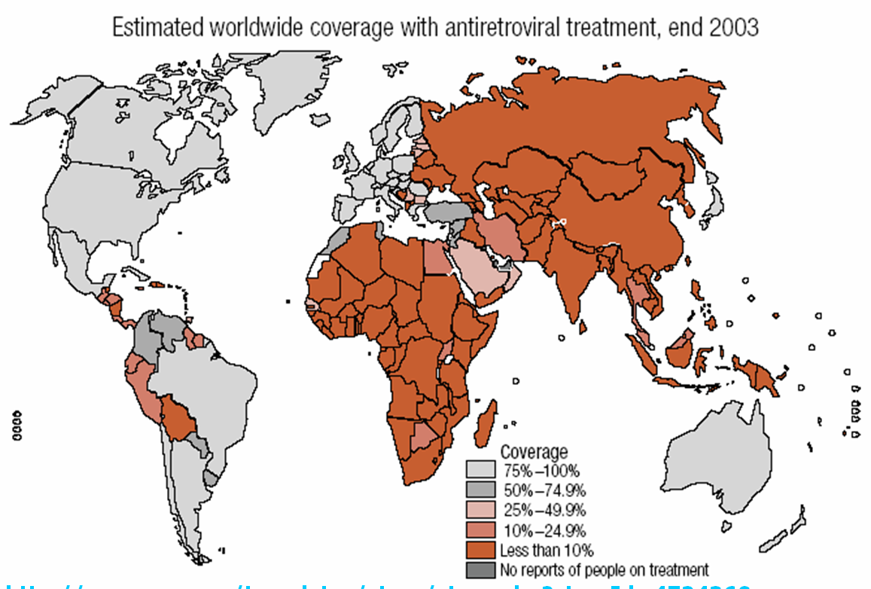

- In 1994, the WHO published estimates of the expected number of new cases of TB as well as deaths due to TB expected throughout the world in 1990, 1995 and 2000. In addition, the WHO published estimates of the fraction of these cases and deaths that were attributed to HIV co-infection. The table below summarizes some of these data.

TB Cases and Deaths in Africa
Year | New Cases of TB | Incidence Rate per 100,000 population | New HIV Attributed TB cases | Deaths due to TB | HIV Attributed TB Deaths
1990 | 992,000 | 191 | 194,000 | 393,000 | 77,000
1995 | 1,467,000 | 242 | 380,000 | 581,000 | 150,000
2000 | 2,079,000 | 293 | 604,000 | 823,000 | 239,000

TB Cases and Deaths in Industrialized Countries
Year | New Cases of TB | Incidence Rate per 100,000 population | New HIV Attributed TB cases | Deaths due to TB | HIV Attributed TB Deaths
1990 | 196,000 | 23 | 6,000 | 14,000 | 500
2000 | 211,000 | 24 | 26,000 | 15,000 | 2,000

- Compare the trends predicted in the incidence rate of TB in Africa to that seen in industrialized countries between 1990 and 2000.

- Calculate the predicted mortality rate of TB per 100,000 population in Africa in 1990 and 2000. Compare that to the mortality rate of TB predicted in industrialized countries in the same period.

(c) Do you think that increases predicted in the incidence of TB in Africa represent demographic changes or epidemiologic changes? Justify your answer.

- Cancer is the second leading cause of death in the United States and annually costs the health care system more than 100 billion dollars.

- What type of cancer is responsible for the greatest number of deaths worldwide?

- Why is the mortality rate so high for this type of cancer?

- Describe the stages of malignant tumor formation and metastasis.

- It is sometimes said that “illness is a cause of poverty”.

  - Explain what is meant by this saying in the context of what we learned in Units 1 and 2. You may find it useful to use the specific example of malaria in your answer.

  - How do health systems attempt to protect citizens from the financial burdens associated with illness?

- Define each of the following types of health systems (one sentence each). For each health system, give an example of one country which has that type of health system.

  - Entrepreneurial health system:

  - Welfare-oriented health system:

  - Comprehensive health system:

  - Socialist health system:

  - Compare and contrast the fraction of health expenditures which are paid for from private health spending and out-of-pocket health spending in entrepreneurial and welfare-oriented health systems in developed and developing countries.

- When detected early, ovarian cancer is curable for 95% of women. Unfortunately, in the majority of cases, ovarian cancer is not detected until widespread metastasis has occurred. In this circumstance, ovarian cancer is fatal approximately 63% of the time. The American Cancer Society estimates that there will be about 25,580 new cases of ovarian cancer in the United States in 2004. About 16,090 American women will die of the disease in 2004. On average, 22 years of life are lost when a woman dies of ovarian cancer. You have developed a new blood test that can detect ovarian cancer in the earliest possible stages. Each blood test costs $200 to perform. There are 292 million Americans, approximately 70 million of whom are women over age 40.

  - How much money would we spend annually if all women over age 40 were screened with this new test?

  - Calculate the annual mortality rate of ovarian cancer without the use of the new test. Compare this to the expected annual mortality rate of ovarian cancer with the use of the new test.

  - If the new test was used, how many years of life would be gained?

  - If this test was administered annually to all women over age 40, how many $ would we spend per year of life gained?

  - Based on your answer to part d and our discussions in class, do you think this test would be adopted in the developed world? In the developing world? Explain your reasoning.

- Cholera infection can produce severe diarrhea. The associated fluid loss can lead to severe dehydration and death if untreated.
  - How does cholera produce such severe fluid loss?
  - What is oral rehydration therapy and how does it prevent dehydration associated with severe diarrhea?
- List the four leading causes of death in developed and developing countries for the following age groups:

  - Ages 0-4:

  - Ages 45-59:

  - Compare the differences in causes of mortality in these settings. What is responsible for the differences?

- Cardiovascular disease is the leading cause of death in the United States.

  - What are four major treatments for coronary artery disease?

  - Currently, coronary artery disease is diagnosed using coronary angiography, a painful and expensive technique. You have just developed a new, painless technique to diagnose coronary artery disease. The technique is also substantially less expensive than coronary angiography. Somewhat surprisingly, some health economists predict that the introduction of your new technique will actually cause health care expenditures to grow. Why might they make this prediction?
EXTRA CREDIT:

- The "absolute poverty line" is the threshold below which families or individuals are considered to be lacking the resources to meet the basic needs for healthy living; having insufficient income to provide the food, shelter and clothing needed to preserve health.

According to the 2005 guidelines, what is the absolute poverty line for a family of 4 living in the United States (circle one):

$28,312
$19,350
$14,412
$9,236

- Name two of our four TAs.

